<https://fonts.google.com/?selection.family=Germania+One|Noto+Sans+TC>

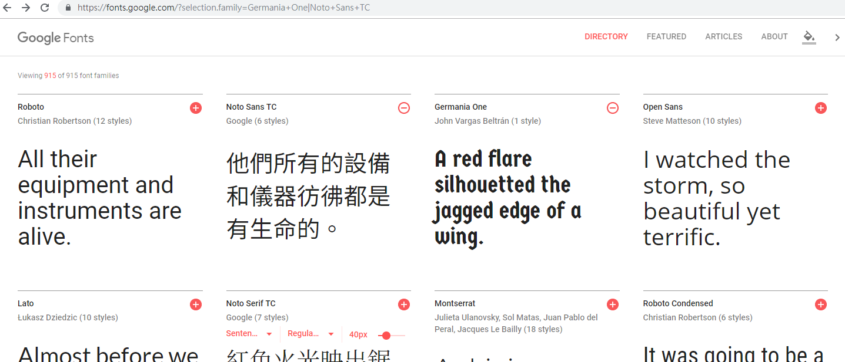

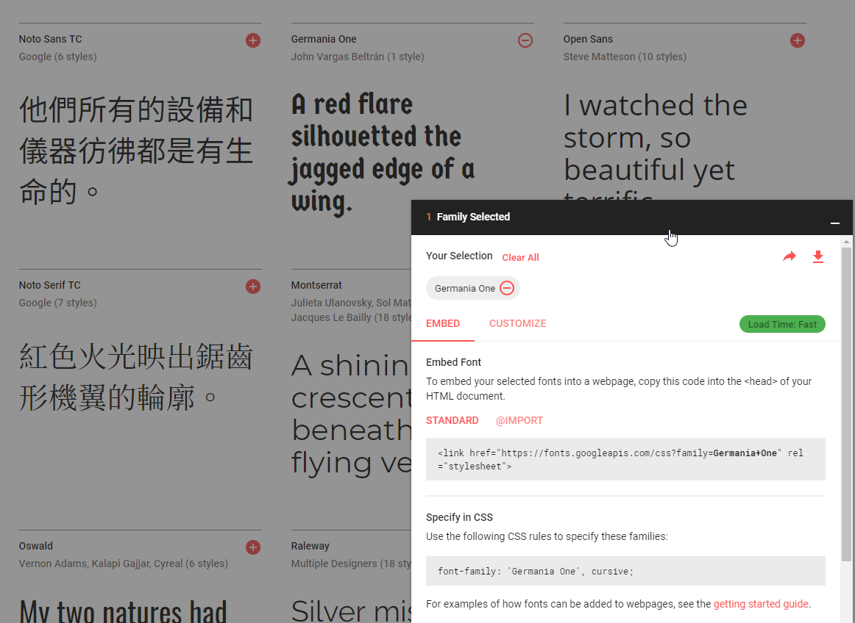

1. <link href="https://fonts.googleapis.com/css?family=**Germania+One**" rel="stylesheet"> 放css.html
2. font-family: 'Germania One', cursive; 放css.css

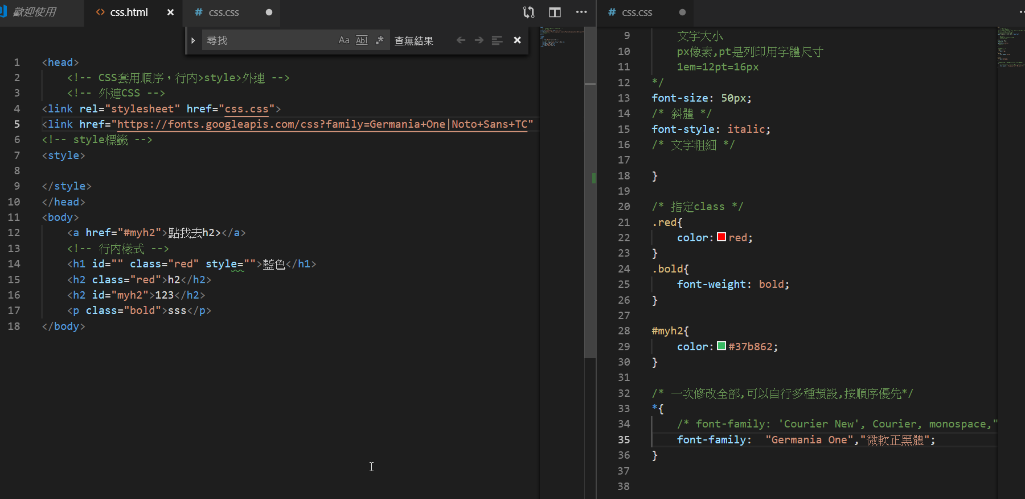

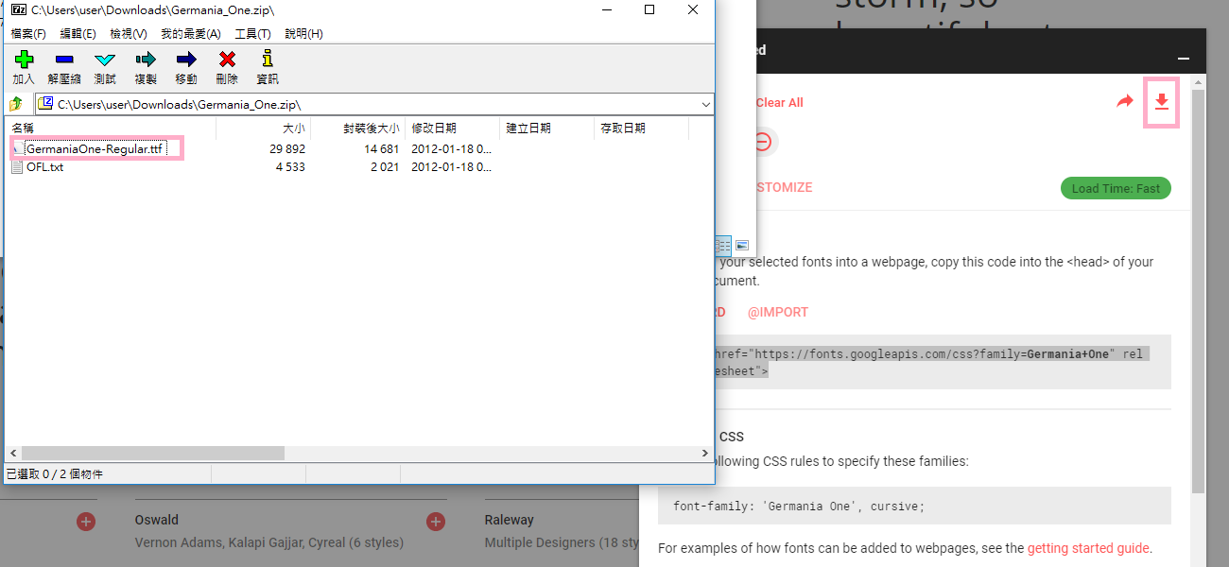

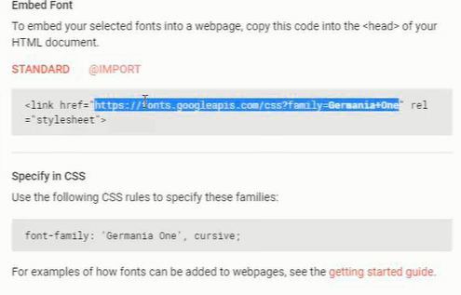

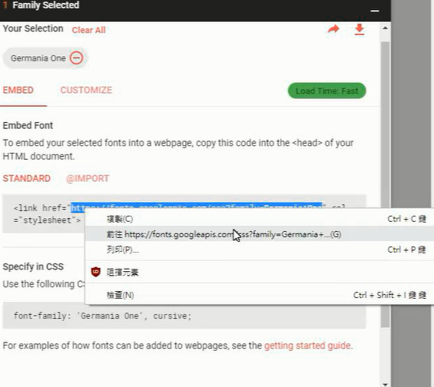

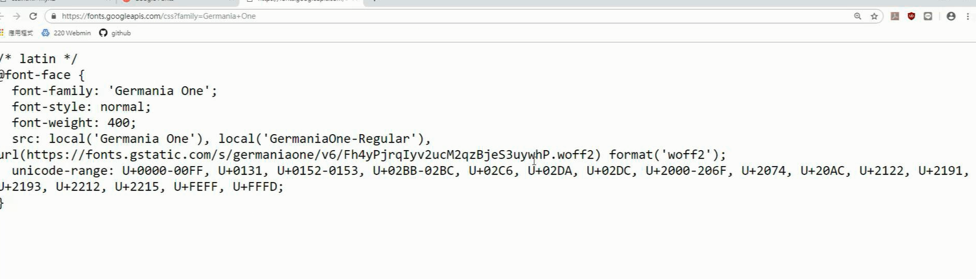

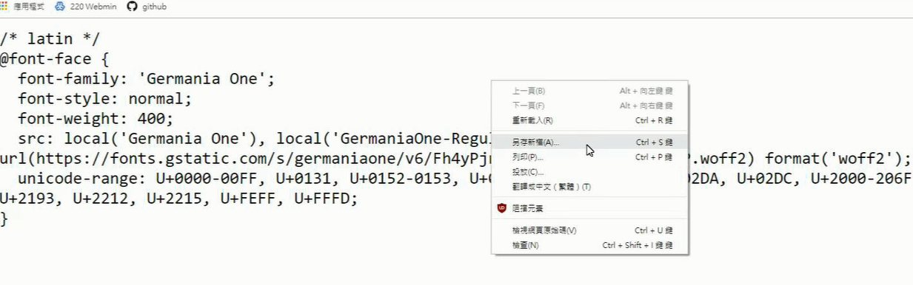

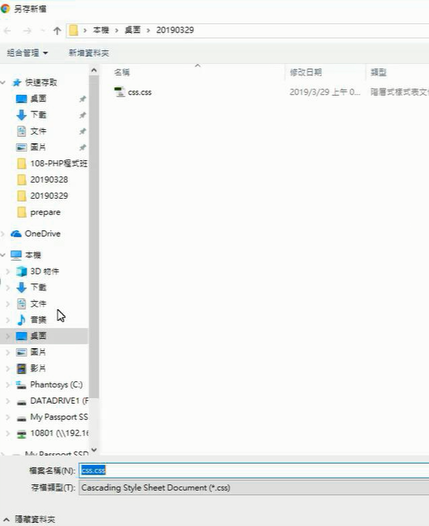

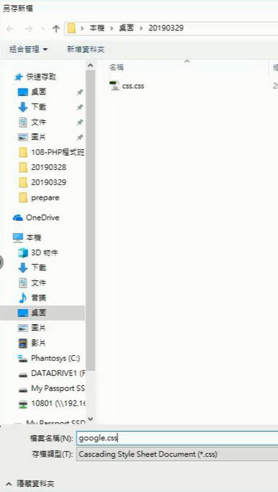

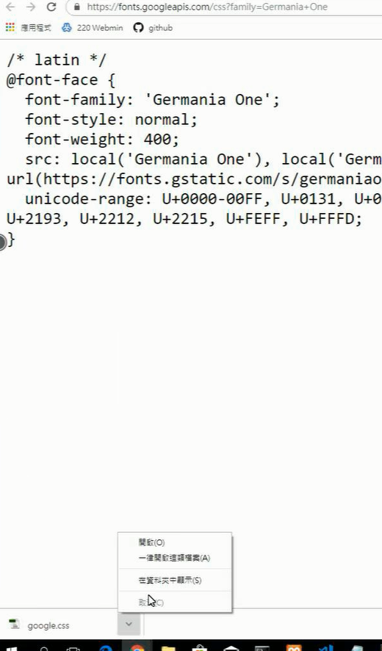

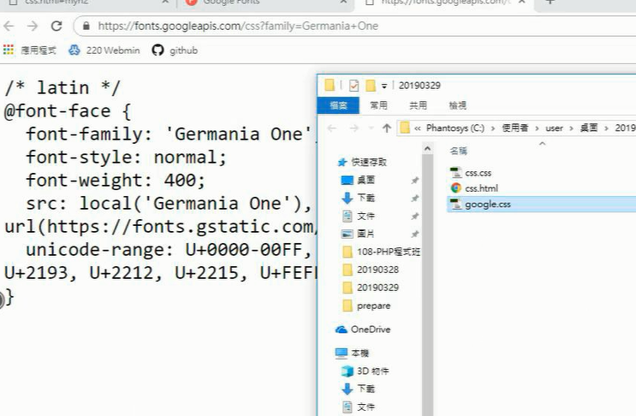

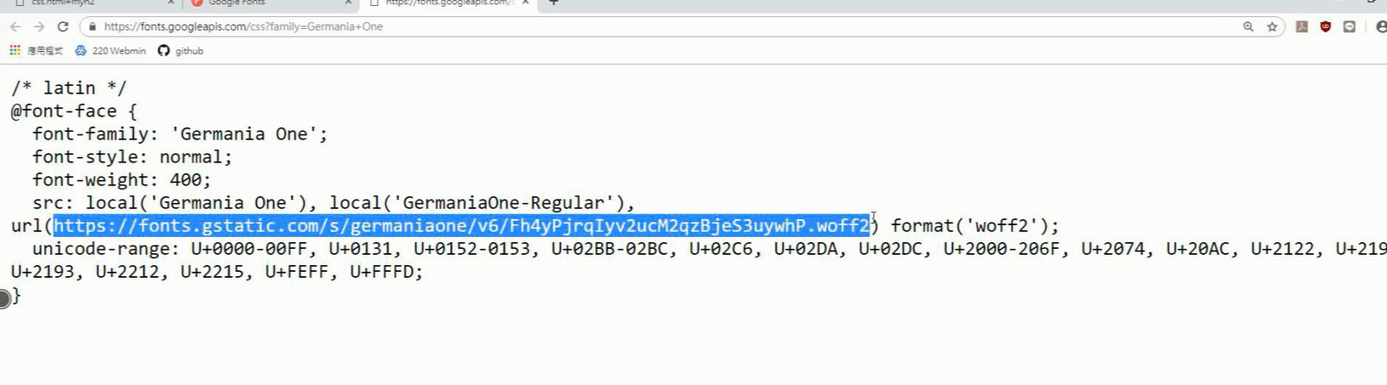

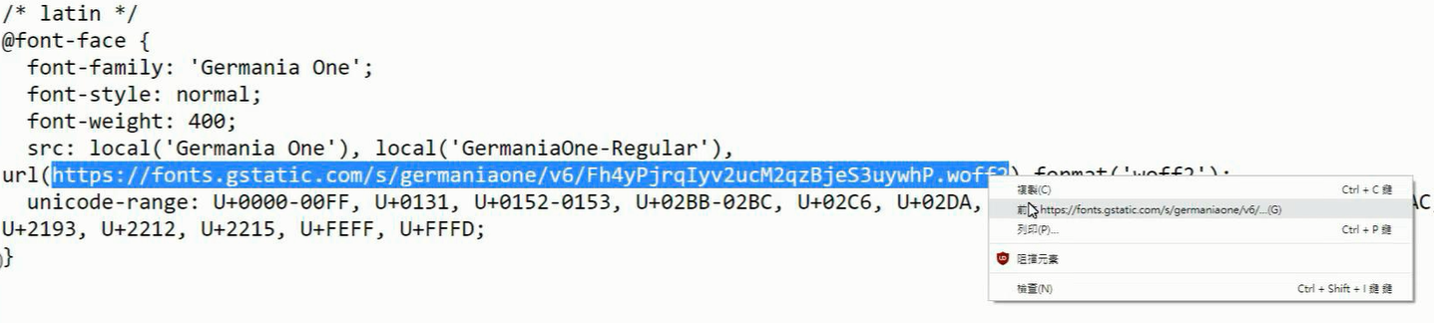

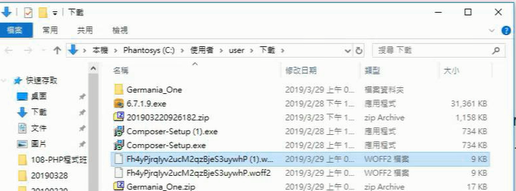

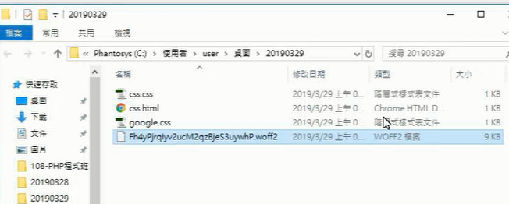

網路連結改成本機

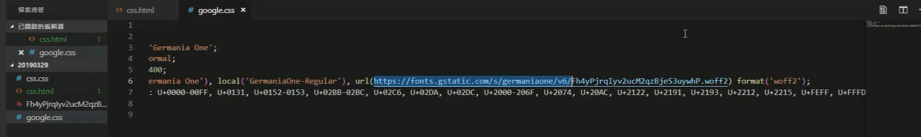

本機路徑

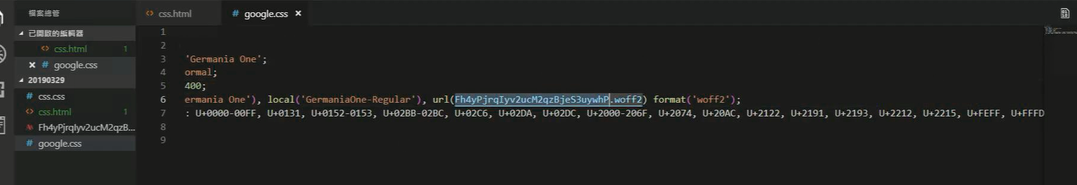

新增CSS與font資料夾

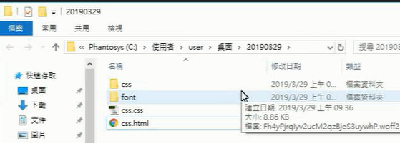

變更相對路徑

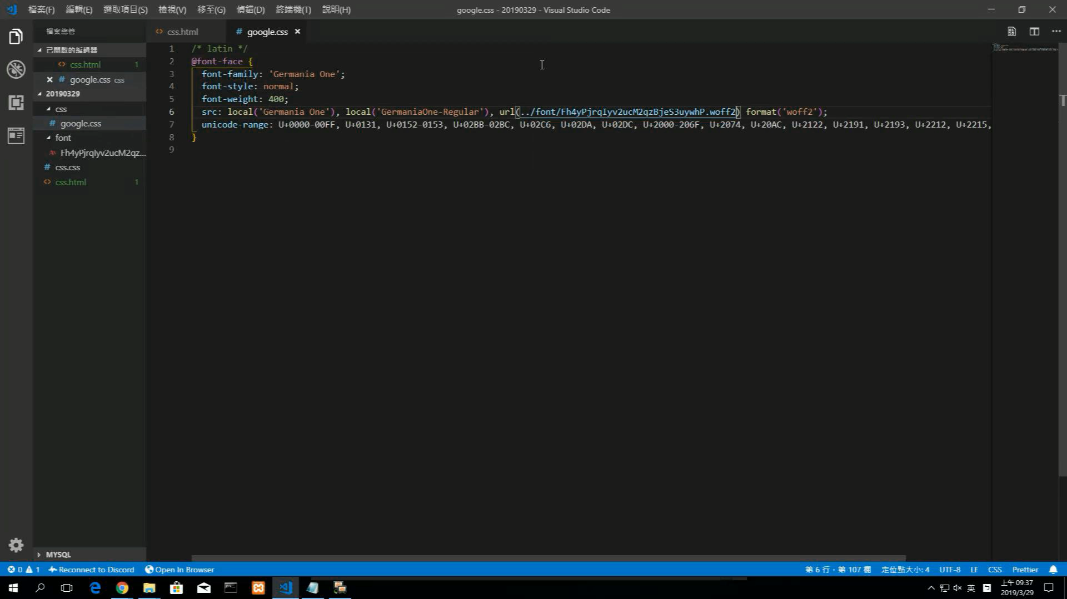

Google.css

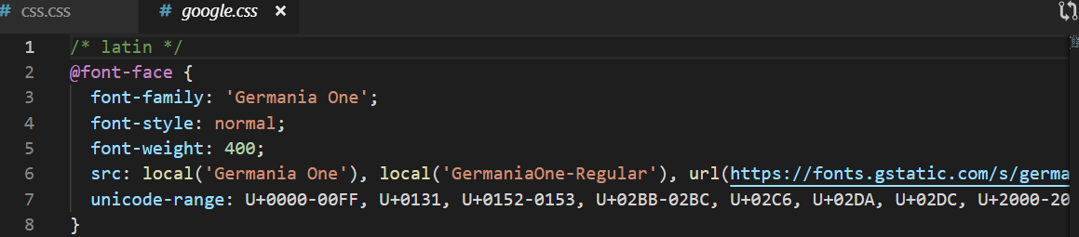

把<https://fonts.gstatic.com/s/germaniaone/v6/Fh4yPjrqIyv2ucM2qzBjeS3uywhP.woff2> 另存為google.css

下載下來的google.css

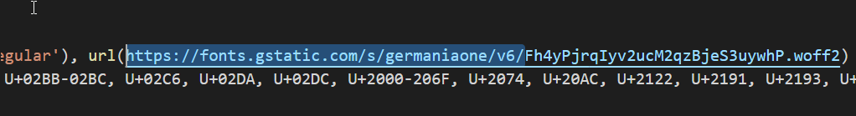

改為本機位置

src: local('Germania One'), local('GermaniaOne-Regular'), url(../font/Fh4yPjrqIyv2ucM2qzBjeS3uywhP.woff2) format('woff2');

css/google.css

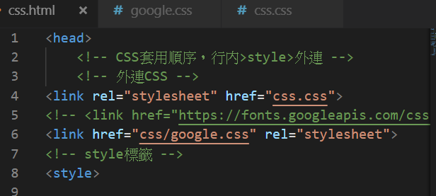

現在有css.html css.css google.css

在下列網址中

<https://fonts.google.com/?selection.family=Germania+One|Noto+Sans+TC>

直接使用google字型

1 <link href="https://fonts.googleapis.com/css?family=**Germania+One**" rel="stylesheet"> 放css.html

2 font-family: 'Germania One', cursive; 放css.css

本機使用:

下載CSS樣式及下載字型檔